

**STANDARD OPERATING PROCEDURE**

**Do not Photocopy**

**Document Information Classification: Unrestricted**

|  |  |
| --- | --- |
| **Title:** | **Use of Q-Pulse** |
| **Effective Date:** | **09 May 2019** |
| **Reference Number:** | **SOP-02-06** |
| **Version Number:** | **2.5** |
| **Owner:** | **ISMS Management Process Owner,** |
| **Review Date:** | **06 Sep 2020** |

Table of Contents

1. Purpose 3

2. Scope 3

3. Responsibilities 3

4. Procedure 3

4.1. Use of Web Q-Pulse – Basic user interactions 3

4.1.1. Accessing the web version of Q-Pulse 3

4.1.2. Accessing documents 5

4.1.3. Acknowledging documents 7

4.1.4. Change requests 8

4.1.5. Using Wizards 9

4.2. Use of Desktop Q-Pulse – basic user interactions 10

4.2.1. Accessing Q-Pulse 10

4.2.2. Accessing documents 10

4.2.3. Acknowledging Documents 11

4.2.4. Change requests 12

4.2.5. Using Wizards 13

4.3. Line Manager Interactions 15

4.3.1. Updating Person Records 15

4.3.2. Reviewing Assets 18

4.4. Process owner interactions 20

4.4.1. Creating a new document record 20

4.4.2. Reviewing and revising a document 22

4.4.3. Responding to change requests 23

4.4.4. Activating and distributing documents 24

5. Cross Referenced ISMS Documents 24

6. Appendices 24

1. Purpose

All employees of the organization should receive appropriate awareness education and training and regular updates in procedures, as relevant for their job function. Operating procedures should be documented and made available to all users who need them.

This document provides details of how to interact with Q-Pulse for basic users and also to how complete responsibilities in Q-Pulse for more specific Information Security Management System (ISMS) roles. It should be used as guide on how to use the different Q-Pulse modules and how to record any necessary information in Q-Pulse.

1. Scope

This document covers basic user and role specific instructions for how to use Q-Pulse for the ISMS.

1. Responsibilities

There are no additional responsibilities specific to this user guide.

1. Procedure



Q-Pulse is a software application focused on quality, compliance and improvement that is used to manage the ISMS in line with regulatory and stakeholder requirements.

Q-Pulse consists of a number of modules. The most commonly used modules are:

* Documents: Used for reading, approving, reviewing and securely storing all documentation.
* Actions: Used for raising and managing all non-compliances and improvement ideas.
* Audit: Used to manage all stages of any audit occurring in the organisation.

Other modules include Assets, Customers, TRE Projects, People and TRE User Accounts and Training and Qualifications.

Q-Pulse is used to document all actions, audits, documents, assets and people under the scope of the ISMS.

* 1. Use of Web Q-Pulse – Basic user interactions

This section documents the general interactions most Q-Pulse users will have with Q-Pulse. Basic users will only require access to the web version of Q-Pulse as the majority of actions can be completed in this version. The Web version only allows access to a sub-set of modules: Documents, Actions and Audits.

* + 1. Accessing the web version of Q-Pulse
* From your web browser navigate to <https://qpulse.herc.manchester.ac.uk/QPulseWeb/UI/Open/Login.aspx>

this will display the Q-Pulse login screen

Note: the Web version is only fully supported on Internet Explorer.

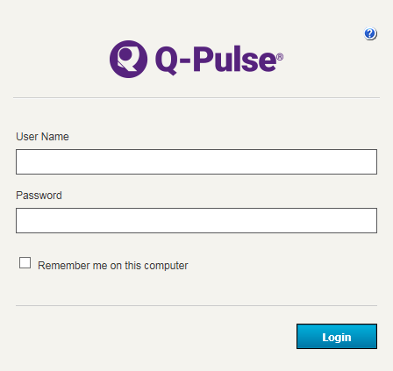

* Enter your username and password and click on the ‘Login’ button. Note: passwords are case sensitive. This will display your Launchpad.

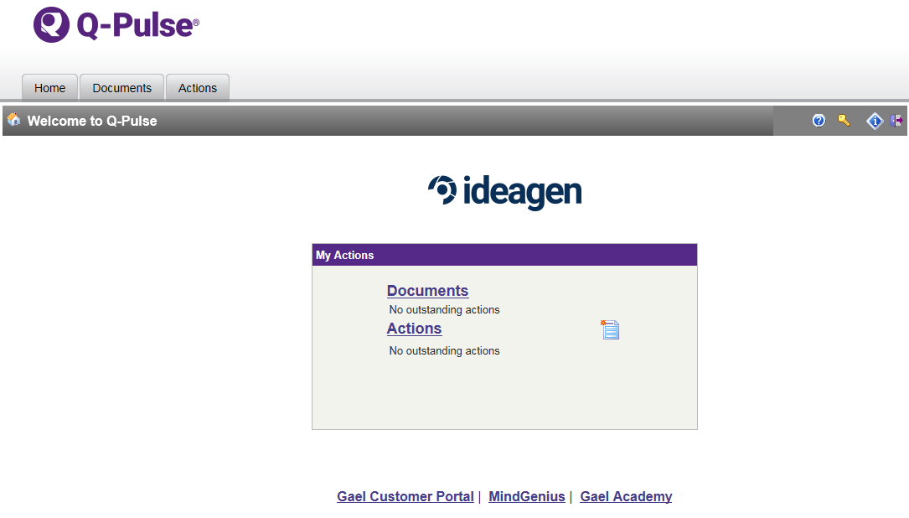

* Icons on the Launchpad toolbar

 Use this icon to access the help files for Q-Pulse. This icon provides access to all help documents and introductions to each module.

 Use this icon to reset your password

 Use this icon to access the “About” window, includes information about the Q-Pulse version

 Use this icon to log out of Q-Pulse. This icon should be used whenever any user has completed their interaction with Q-Pulse. All users are advised to log out of Q-Pulse as soon as they finish interacting with the system as there are limited licenses available for use.

* My Actions dashboard:

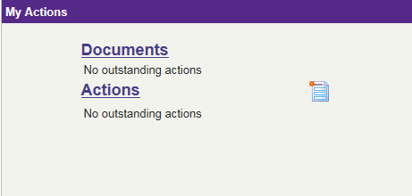

* This dashboard will display any outstanding, or imminently due, actions in each of the available modules. You will be able to navigate directly to your action by clicking on the action type.
*  This icon can be used to access any wizard that is available from the launch pad. Wizards can be used by any user to quickly report security events, weaknesses or opportunities.
  + 1. Accessing documents
* To access the documents module click on the ‘Documents’ tab on the toolbar, or the purple ‘Documents’ title on the ‘My Actions’ dashboard.
* You will then see the following screen

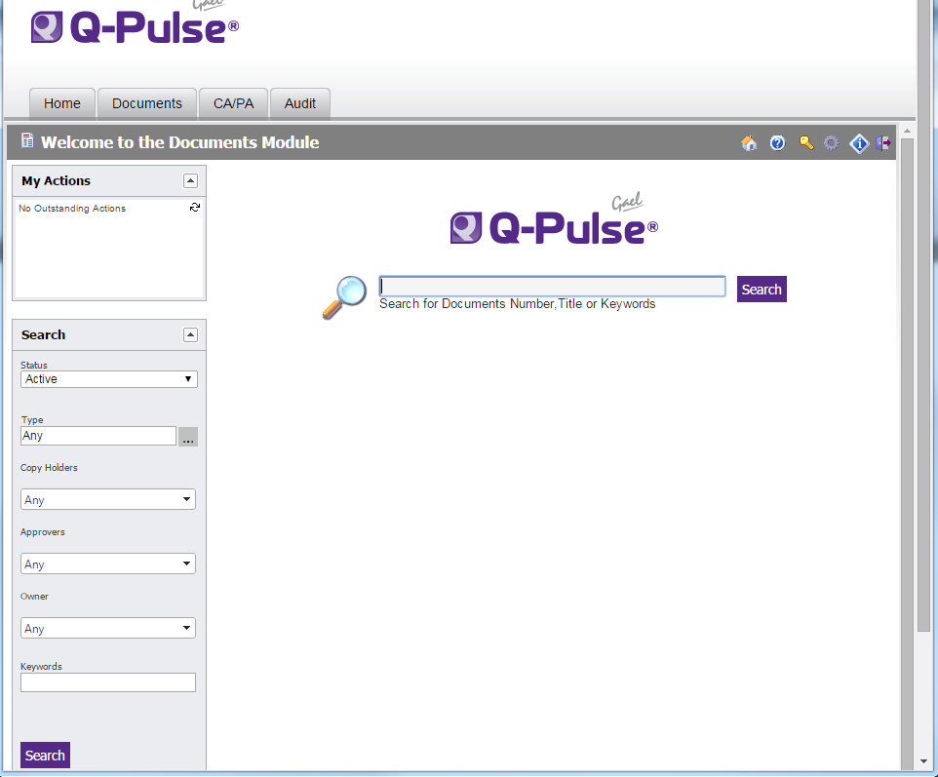

* To quickly access all of the ISMS documents available to you open the ‘My Searches’ box and select ‘My Notified Documents’.

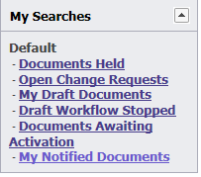

* You can also search for a document by using the central search box. Searches can be done on the full/part document numbers, keywords or title. e.g. “SOP” would bring back all documents with SOP in the title or document number. Note: only the ISMS documents that you have been given access to will be returned by this search.
* A search can also be done on other criteria by using the search box on the left of the screen. e.g. a user could find all documents he/she was required to acknowledge by entering their name in the ‘Copy Holder’ dropdown. The search is activated by clicking the search button.
* Once a search is complete you will see a screen similar to the following (note this screenshot is not representative of the documents in CHI’s Q-Pulse system).

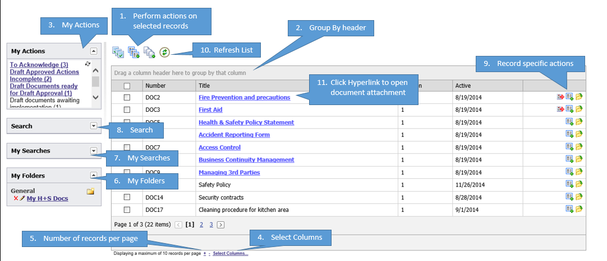

* Click on the hyperlink to view the document.. To avoid working with out of date documents the version you open should not be saved on your computer and users should only use documents directly from Q-Pulse.
* For each document record there are specific action icons that may be available (dependent each specific document status):

 Acknowledge Document

 Access a list of referenced documents

 Raise a change request

 Open the document properties

* + 1. Acknowledging documents
* Acknowledging a document indicates that you have read the document and that you will use the document in future actions. Acknowledging should be done as soon as practical after you are notified (usually via email) of the requirement to acknowledge a new document or version.
* The Launchpad will also provide a prompt if any document actions are outstanding:

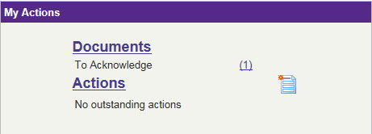

* To list the documents to acknowledge click on the number on the Launchpad or the appropriate action in the My Actions window.

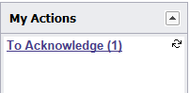

* A list of the documents you are required to acknowledge will be displayed.
* Read the documents.
* Tick the box next to each document and then click the  icon at the top of the screen or the icon alongside the document record. You will be required to enter your Q-Pulse username and password to confirm your electronic signature.

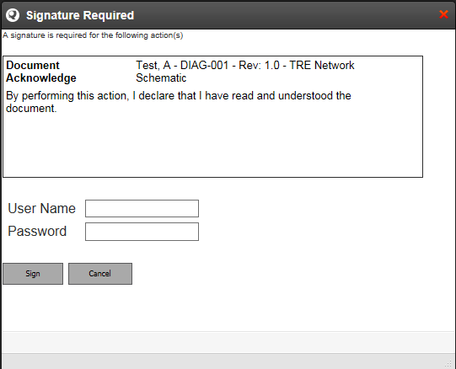

* + 1. Change requests

Change requests may be raised by any Q-Pulse user against the documents they can access in the document register. Proposals for change requests should preferably first be discussed with the document/process owner and should only be raised if there is a process error in a document or to suggest a process improvement – please note that the process owner will have to approve such suggestions and may choose not to implement some changes.

* To raise a change request click on the icon next to the relevant document in the document list view.
* Enter your change request details:
  + **Details:** Enter as much information as possible to assist the document owner when updating the document.
  + **Supporting Information:** You can also add attachments to assist the document owner (e.g. you may have updated the document yourself already).
  + **Raised By / Raised Date:** These will default to your name and today's date, but you can change these if required.
  + **Severity:** Select a suitable severity rating for the change request to help the owner prioritise the change requests.
* Click [OK] to save the change request. Once you do this, the owner will be notified and will then either accept or reject the change request.
  + 1. Using Wizards

All users will have access to the various wizards to allow them to report security events and weaknesses or opportunities in Q-Pulse.

* From the Launchpad click the icon.

Select the appropriate wizard from the list.

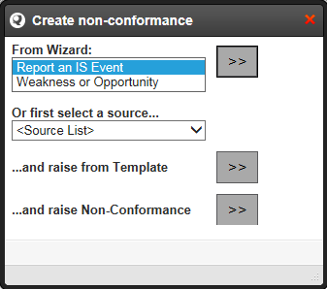

* Click to activate the wizard.
* Complete all mandatory fields marked with *
* Certain wizards may allow the user to attach a file. Q-Pulse can accept any file format, but will reject executables.
* Complete the wizard by clicking Finish. The owner will be notified and will be responsible for managing the action through to closure.
  1. Use of Desktop Q-Pulse – basic user interactions

The desktop version of Q-Pulse will be available to some users. This version of Q-Pulse provides access to all modules although the modules presented will depend on the user’s access rights.

* + 1. Accessing Q-Pulse
* Click the Q-Pulse icon on your desktop



* Enter your username and password: Note: passwords are case sensitive.You will now see your Launchpad.



* Icons on the Launchpad:

 Access to the list of available wizards (note: the list may require updating from time to time by accessing preferences)

 Access to preferences, change password options

 Access to help files for all Q-Pulse interactions.

* The number next to the module title shows you how many actions you have to complete in that module. Click on the number to be taken to a list of your actions.
* Click on a module title to access the module.
  + 1. Accessing documents
* Enter the documents module by clicking the ‘Documents’ link from the Launchpad.
* You will then see the following document list view:

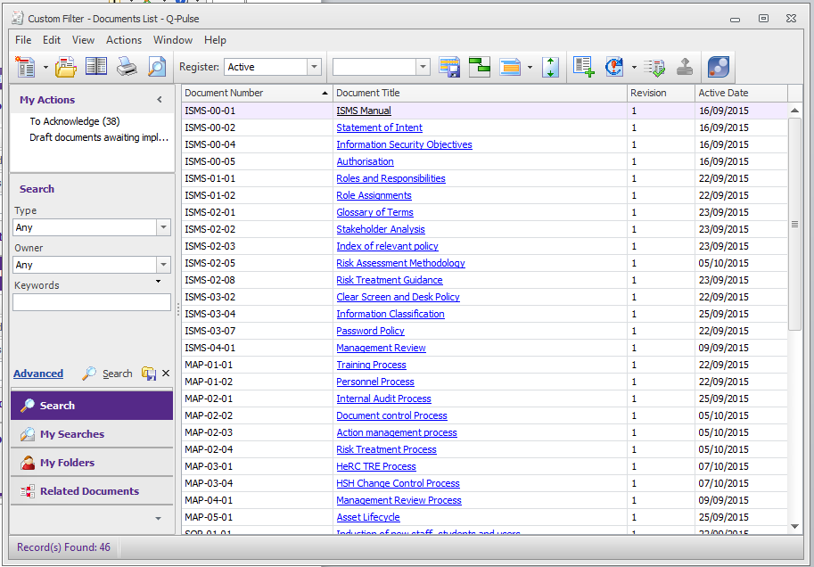

* The list view will display all of the ISMS documents that are applicable to your role. Some will have been mandated for your acknowledgement and some are provided for reference only and do not have to be read and acknowledged.
* To access a document click on the hyperlink
* To access the record card for the document double click on the document number.
* Additional columns may be added to the view by right clicking the toolbar and selecting Column Chooser

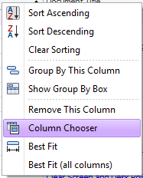

* Columns may be removed by dragging the header off the toolbar until a black cross is seen, release the header to remove it from your view.
  + 1. Acknowledging Documents

Acknowledging a document indicates that you have read the document and that you will use the document in future actions. Acknowledging should be done as soon as practical after you are notified (usually via email) of the requirement to acknowledge.

* To acknowledge a document click on the appropriate action in the My Actions window.



* A list of the documents you are required to acknowledge will be displayed.
* Read the documents.
* Highlight the documents you want to acknowledge from the document list view.
* Click the  icon on the toolbar.
* Save the document records using the  icon
* You will then be prompted for your username and password to complete your electronic signature. Please note that you will be required to enter your password for each document you acknowledge.

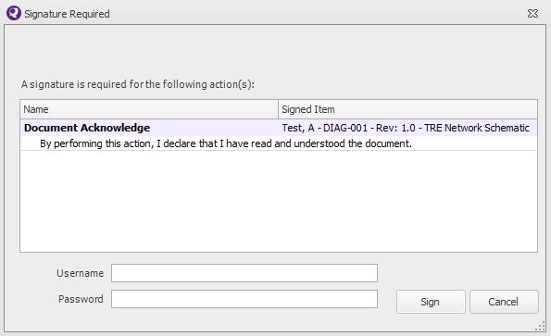

* + 1. Change requests

Change requests may be raised by any Q-Pulse user against the documents they can access in the document register. Proposals for change requests should preferably first be discussed with the document/process owner and should only be raised if there is a process error in a document or to suggest a process improvement – please note that the process owner will have to approve such suggestions and may choose not to implement some changes.

* Highlight the document you want to raise the change against on the document list view
* Click  on the toolbar. This icon can also be accessed from the document record card.
* Enter your change request details:
  + **Details:** Enter as much information as possible to assist the document owner when updating the document.
  + **Supporting Information:** You can also add attachments to assist the document owner (e.g. you may have updated the document yourself already).
  + **Raised By / Raised Date:** These will default to your name and today's date, but you can change these if required.
  + **Severity:** Select a suitable severity rating for the change request to help the owner prioritise the change requests.

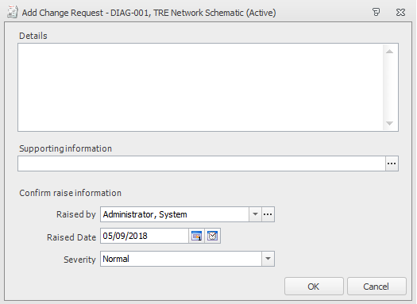

* Click [OK] to save the change request. Once you do this, the owner will be notified and will then either accept or reject the change request.
  + 1. Using Wizards

All users will have access to the various wizards to allow them to report security events and weaknesses in Q-Pulse.

From the Launchpad click the  icon to see a list of available wizards.

* Wizards may be created by the Q-Pulse System Administrator and will not appear in your wizard list unless you update it from time to time by accessing your preferences . Select Preferences from the list and then select Launchpad. Tick the wizards you want to display (recommended to select all) from the section shown below:

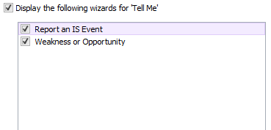

* To run the wizard select the appropriate wizards from the list generated by the  icon.
* Complete all mandatory fields marked with  (only visible when you click next)
* Certain wizards may allow the user to attach a file. Q-Pulse can accept any file format, but will reject executables.
* Complete the wizard by clicking Finish. The owner will be notified and will be responsible for managing the action through to closure.

**NOTE: The following sections are for specific roles or users with specific responsibilities. It is not necessary for basic users to read the remaining sections of this document.**

* 1. Line Manager Interactions

Line managers have high-level responsibilities in Q-Pulse that involve editing Person records and interrogating the Asset register. **It is not necessary for users with no line management responsibility to read this section of the document.**

* + 1. Updating Person Records

If you are a line manager you will be responsible for adding starter and leaver checklists to the person records for your team.

* Enter the People module by clicking on the ‘People and TRE User Accounts’ link from the Launchpad. This will display the list of all employees.

Screenshot removed

* Double click on the record for the person you wish to update to display the record card for that person. Note: if the record details are grayed out then you do not have access to update the details for this person and should inform the Q-Pulse System Administrator (xxxxxxxxxx)

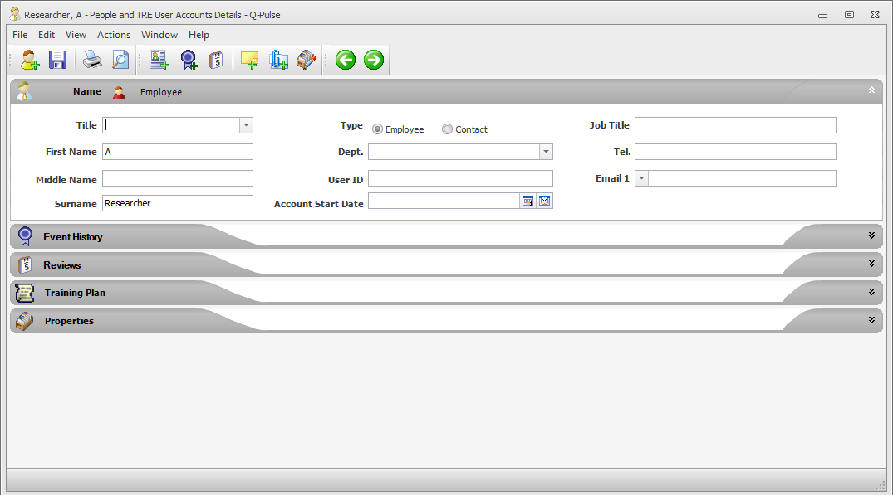

* To add a file attachment such as the starter and leaver checklist, use the Actions -> Add Attachment options form the menu.

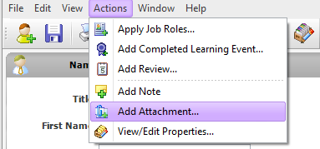

* This displays the ‘Edit Attachment’ dialog

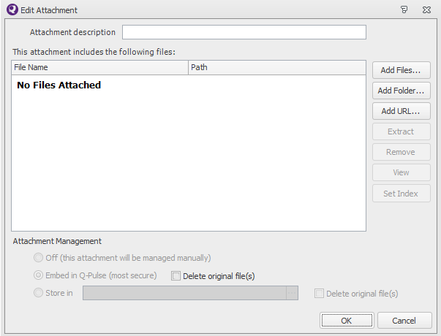

* Use the ‘Add Files’ button to access Windows Explorer and locate the file you wish to attach.
* When the file has been added the Person Record should be saved using the  icon.
  + 1. Reviewing Assets

When an employee leaves it is the responsibility of the line manager to ensure their assets have been returned.

* Enter the Assets module by clicking on the ‘Assets’ button on the Launchpad.

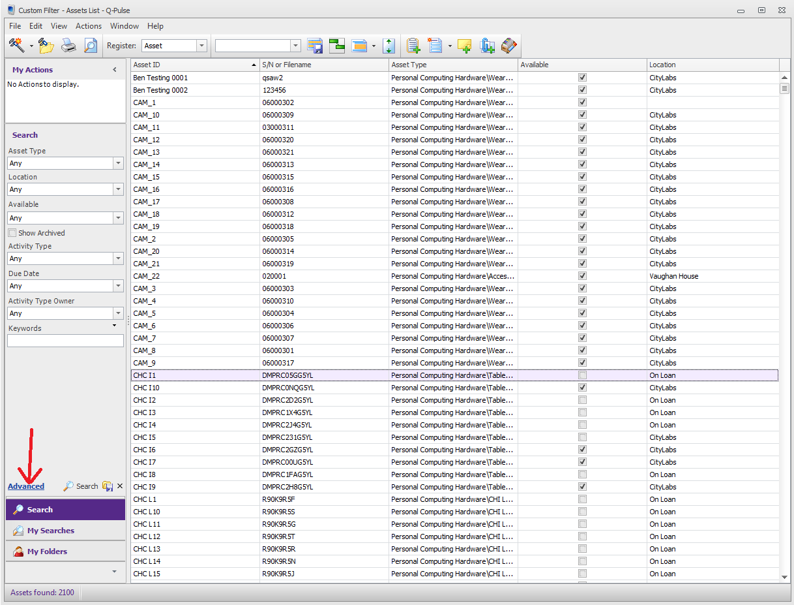

* To identify the assets owned by a particular employee click on the ‘Advanced’ search button.
* Set the search criteria to be ‘Assigned To’ and the name of the employee (in the screen shot below the employee is set to Administrator, System.)

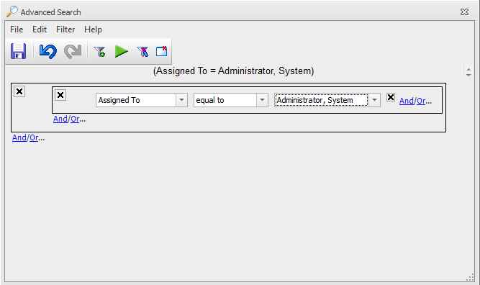

* Click on the  icon to execute the search. This will return a list of all of the assets assigned to the selected employee.

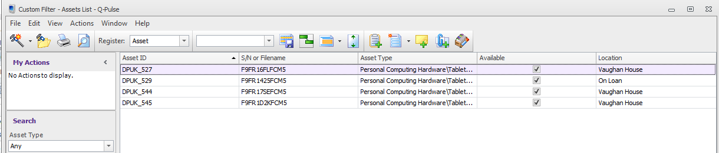

* Once the assets have been returned please inform CHI Staff Administration (xxxxxxxx) who will update the ownership details in Q-Pulse.
  1. Process owner interactions

Process owners have high-level responsibilities in Q-Pulse which can involve creating documents in draft format, Process owners do not have the ability to delete any records. **This section of the document is only necessary for Process Owners to read.**

* + 1. Creating a new document record

New documents (do not use this section for revised documents – follow 4.3.2) can only be created in draft format, unless they are already active documents in day to day use, in which case they can only be created by the ISM or Q-Pulse Administrator.

* A new draft document record can be created directly from the LaunchPad by expanding the document module header, and then by selecting New> Document > Draft.
* Alternatively, the new document record can be generated from within the Documents module by selecting the arrow next to  from the toolbar shown below.
* 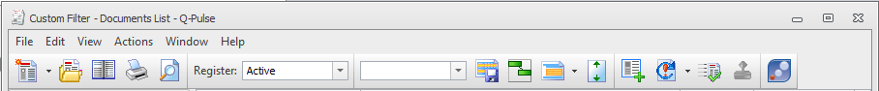
* You will then see the following options:

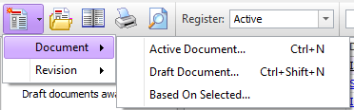

Select Document and Draft Document – Active document will be greyed out.

* The following window will open:

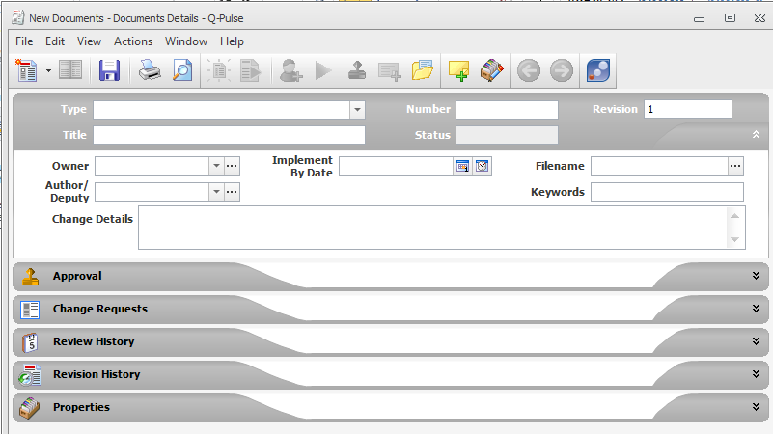

* Enter the following details:
  + **Type:** select the document type from the dropdown list. Select the lowest applicable child in the document hierarchy.
  + **Title:** The title of the document as it appears on the document title page
  + **Number:** automatically generates when the type is selected. This number can be edited if necessary but generally it should not need to be.
  + **Revision:** generated automatically but may be edited if necessary
  + **Owner:** the Process owner’s name
  + **Author/Deputy:** the name of the person that can deputise for the process owner – typically the author’s name.
  + **Implement by date:** should be set no later than 2 weeks from the date the record was corrected.
  + **Filename:** Click the ellipsis icon to navigate the file you want to associate with the record. Once selected the file will be embedded into Q-Pulse. The title of the file can be edited in the attachment description box if the file name is not representative of the file title

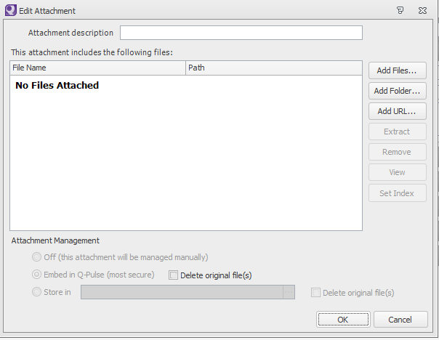

* + **Note:** several files, a folder or URL may be attached to a record. Q-Pulse will reject executable files. Video may be attached, however, if it takes a long time to import into Q-Pulse it will also take a long time to access the file.
  + Click OK to close the file attachment window.
* Expand the Approval section on the document record card and edit/create an approver list by selecting the appropriate icons on the right side of the section. See SOP-02-01 for approval list rules.
* The approvers list can be work flowed. Workflows ensure that the approvers see the document in a sequence rather than all having access to the draft document at the same time. It is advised that approval lists are work-flowed.
* To workflow an approval click the  icon on the right of the Approval section
  + You will then see the following screen

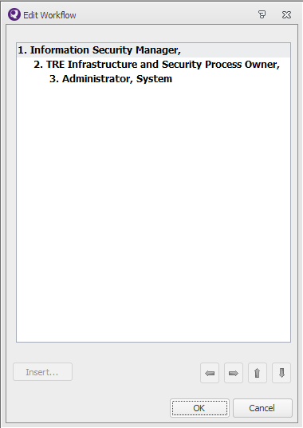

* + Use the arrow keys at the bottom of the window to move and indent the approvers.
  + Moving approvers to the right will make them see the document after anyone to the left of the list
  + An example work flowed list is shown below



Person 1 sees the document first, then person 2 and finally person 3.

* + Click ok to apply the workflow to the approval list.
  + When the record and embedded document is ready, click the green arrow (either in the approval section or the toolbar of the document record) to send the approval request to the selected approvers in the list. Q-Pulse will now email the first person in the work-flowed list.
    1. Reviewing and revising a document

Document reviews can be performed at any point in the active document’s lifecycle, but typically reviews will be performed either as part of an audit or when indicated by the review date. Process owners are responsible for performing and recording document reviews.

* Document reviews are performed in the Review History section of the document record card.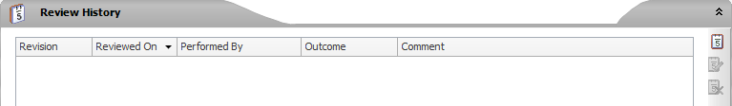
* After reviewing the document, the process owner should record the review by clicking the  icon.
* The following window will open:

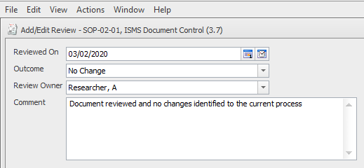

* Record the outcome by selecting the appropriate response from the drop down list:
  + No change – Enter a comment in the comment box to support that the document is still appropriate for use.
  + Change Required – Enter a comment in the comment box to document they type of change required, whether the change is required immediately or if the change can be delayed. The comment should be specific and detailed enough to be understood by an auditor at a later date.
* Click OK to complete the review. Q-Pulse will automatically update the review due date.
* If changes are required on the document the Process owner is required to raise a change request on the document.
* If the change is urgent a draft process should be initiated by the process owner. See 4.3.3 for details.
* Revising a document means to create a new draft. This should be done whenever a document requires a change.
* Click  to start the draft process and then select Draft (with Approval). Q-Pulse will generate a draft record card for the document after the process owner completes the draft wizard. SOP-02-01 provides specific details of how to manage draft documents.
  + 1. Responding to change requests

Process owners are responsible for responding to change requests.

* Q-Pulse will notify the appropriate process owner when a change request has been raised.
* The process owner should access the document record card and view the change request.

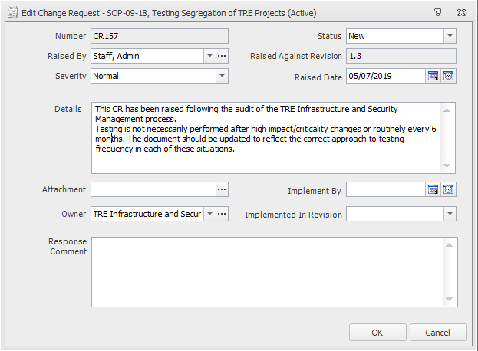

* The process owner shall read the change request and any attachments and decide if the change request is appropriate.
* The process owner will then change the status of the change request to Accepted or Rejected.
* A response comment will be required for either response. Responses should include reasons for not accepting the request or a statement of when the change request will be implemented (if accepted), e.g. this change request is not urgent and will be implemented when the document is next revised.
* Click OK to close the window.
* The person that raised the change request will be notified that there has been a response.
* The process owner shall commence the draft document process if the document requires immediate update. Other less urgent change requests may wait until the document is next revised.
  + 1. Activating and distributing documents

Activation of draft documents is the final stage of the draft document process and can only be completed by Q-Pulse Administration.

1. Cross Referenced ISMS Documents

|  |  |  |
| --- | --- | --- |
| Number | Type | Title |
| SOP-02-02 | ISMS\SOP\ISMS Management - SOP | Reporting Security Events |

1. Appendices

None